NEW YORK CITY MV COLLISIONS: FINAL PROJECT: PART 1

**Data Profiling in Alteryx**

1. Motor_Vehicle_Collisions – Person:

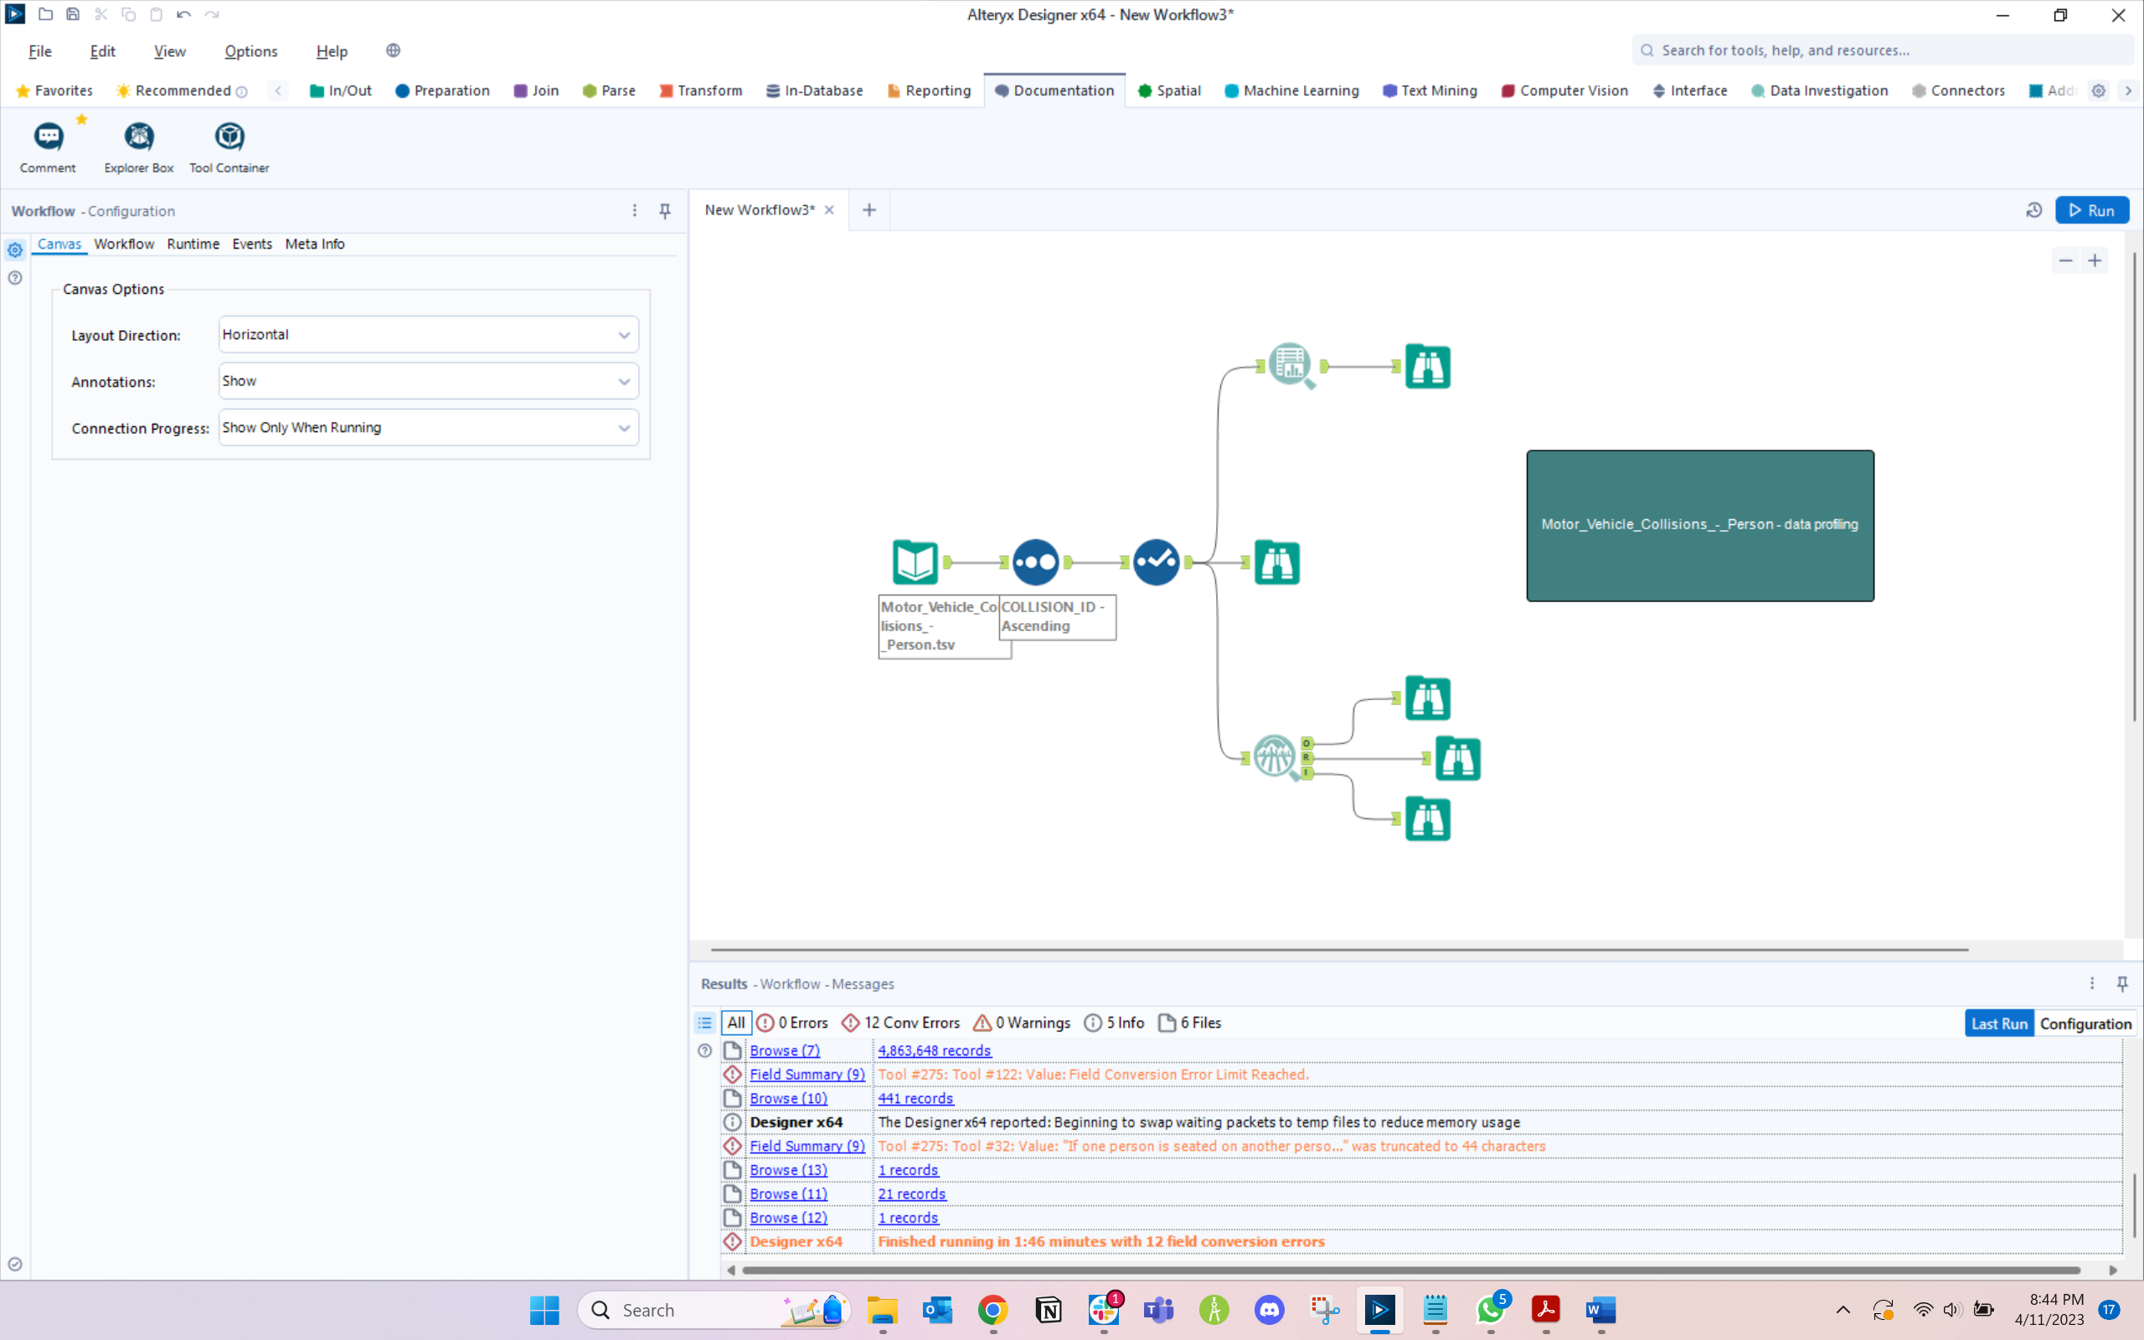

Time Alteryx Job Took: 1:46s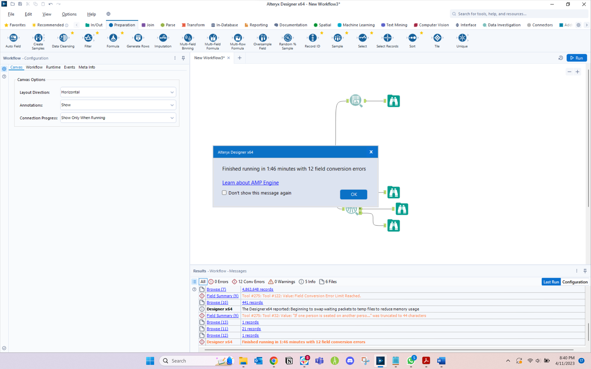

**Data profiling notes - Motor_Vehicle_Collisions_-_Person**

* Person_ID: There are null values in this field that need cleansing - 19 nulls
* Vehicle_ID: There are null values in this field that need cleansing - 193,547 nulls
* Person_Age:

1. There are null values in this field that need cleansing - 485,207 nulls
2. We noticed that values range from -999 to 9999. Age cannot be a negative number nor it can be in a 4 digit number
3. As per prior research, maximum age can be upto 120.
4. Replace all negative ages and ages beyond 100 with the mean value of all the age values
5. And replace NULLs with the mean value

* Ejection: There are null values in this field that need cleansing – 2373445 nulls. We shall replace the null values with “Unknown.”
* Emotional_Status: There are null values in this field that need cleansing – 2306159 nulls. We shall replace the null values with “Unknown.”
* Bodily_injury: There are null values in this field that need cleansing – 2306116 nulls. We shall replace the null values with “Unknown.”
* Position_in_Vehicle: There are null values in this field that need cleansing – 2373097 nulls. We shall replace the null values with “Unknown.”
* Safety_equipment: There are null values in this field that need cleansing – 2373168 nulls. There are records with value “-“ in them which could be replaced with “None”. The null values will be replaced with “Unknown”.
* PED_location: There are null values in this field that need cleansing – 4792093 nulls. We shall replace the null values with “Unknown.”
* PED_Action: There are null values in this field that need cleansing – 4792194 nulls. We shall replace the null values with “Unknown.”
* Complaint: There are null values in this field that need cleansing – 2306109 nulls. We shall replace the null values with “Unknown.”
* PED_Role: There are null values in this field that need cleansing – 194891 nulls. We shall replace the null values with “Unknown.”
* Contributing_Factor_1: There are null values in this field that need cleansing – 4793370 nulls. We shall replace the null values with “Unknown.”
* Contributing_Factor_2: There are null values in this field that need cleansing – 4793465 nulls. We shall replace the null values with “Unknown.”
* Person_sex: There are null values in this field that need cleansing – 554938 nulls. We shall replace the null values with “U” ***

**Field Summary tool:**

Output:

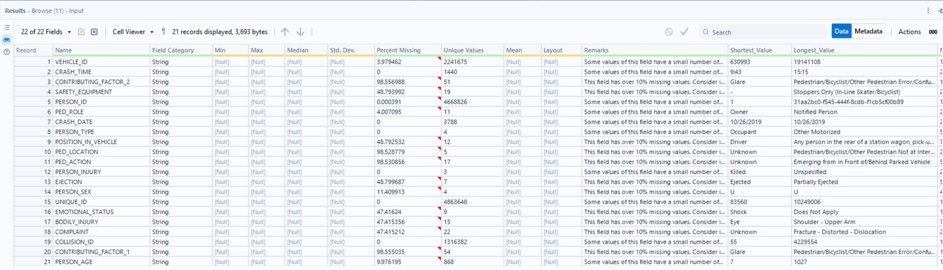

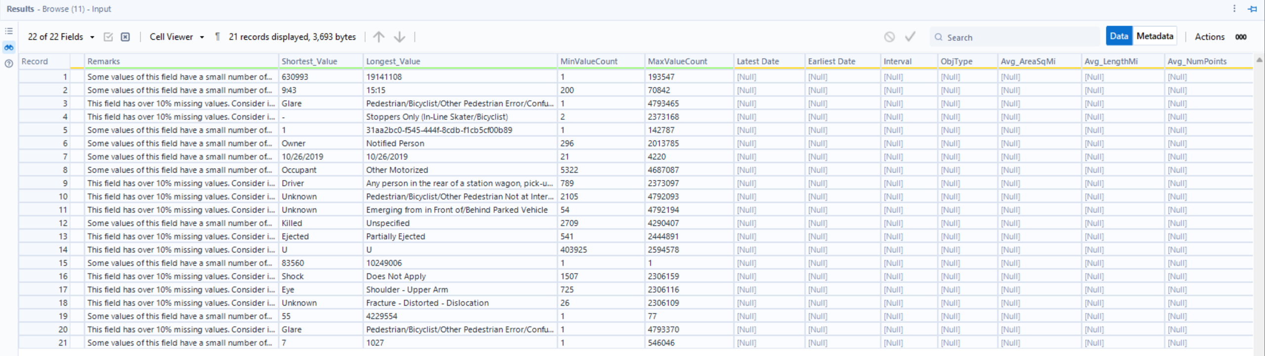

Reports:

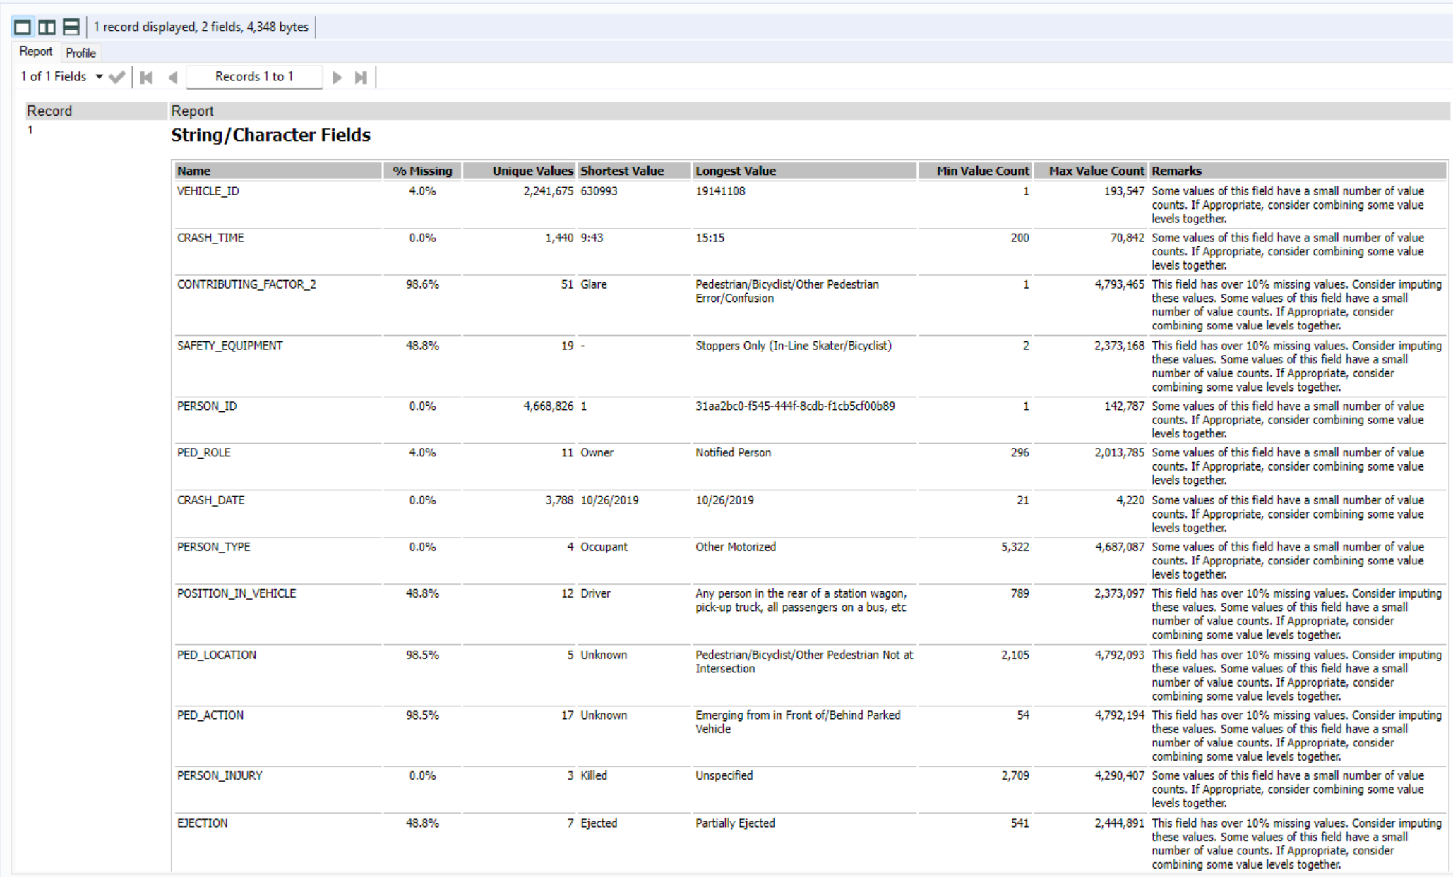

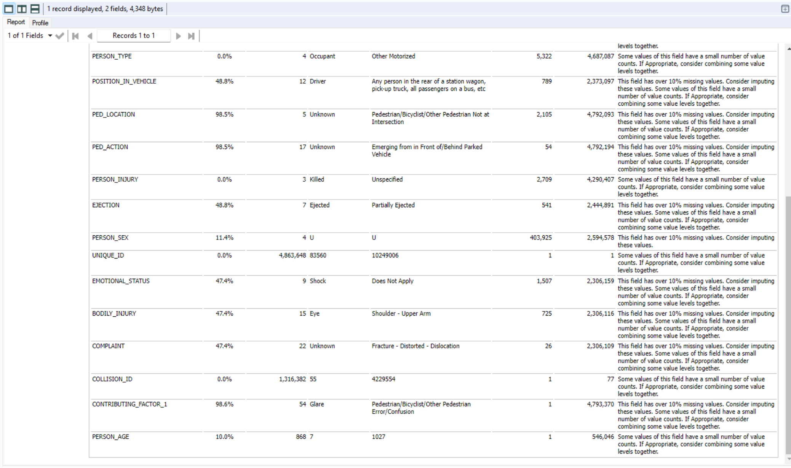

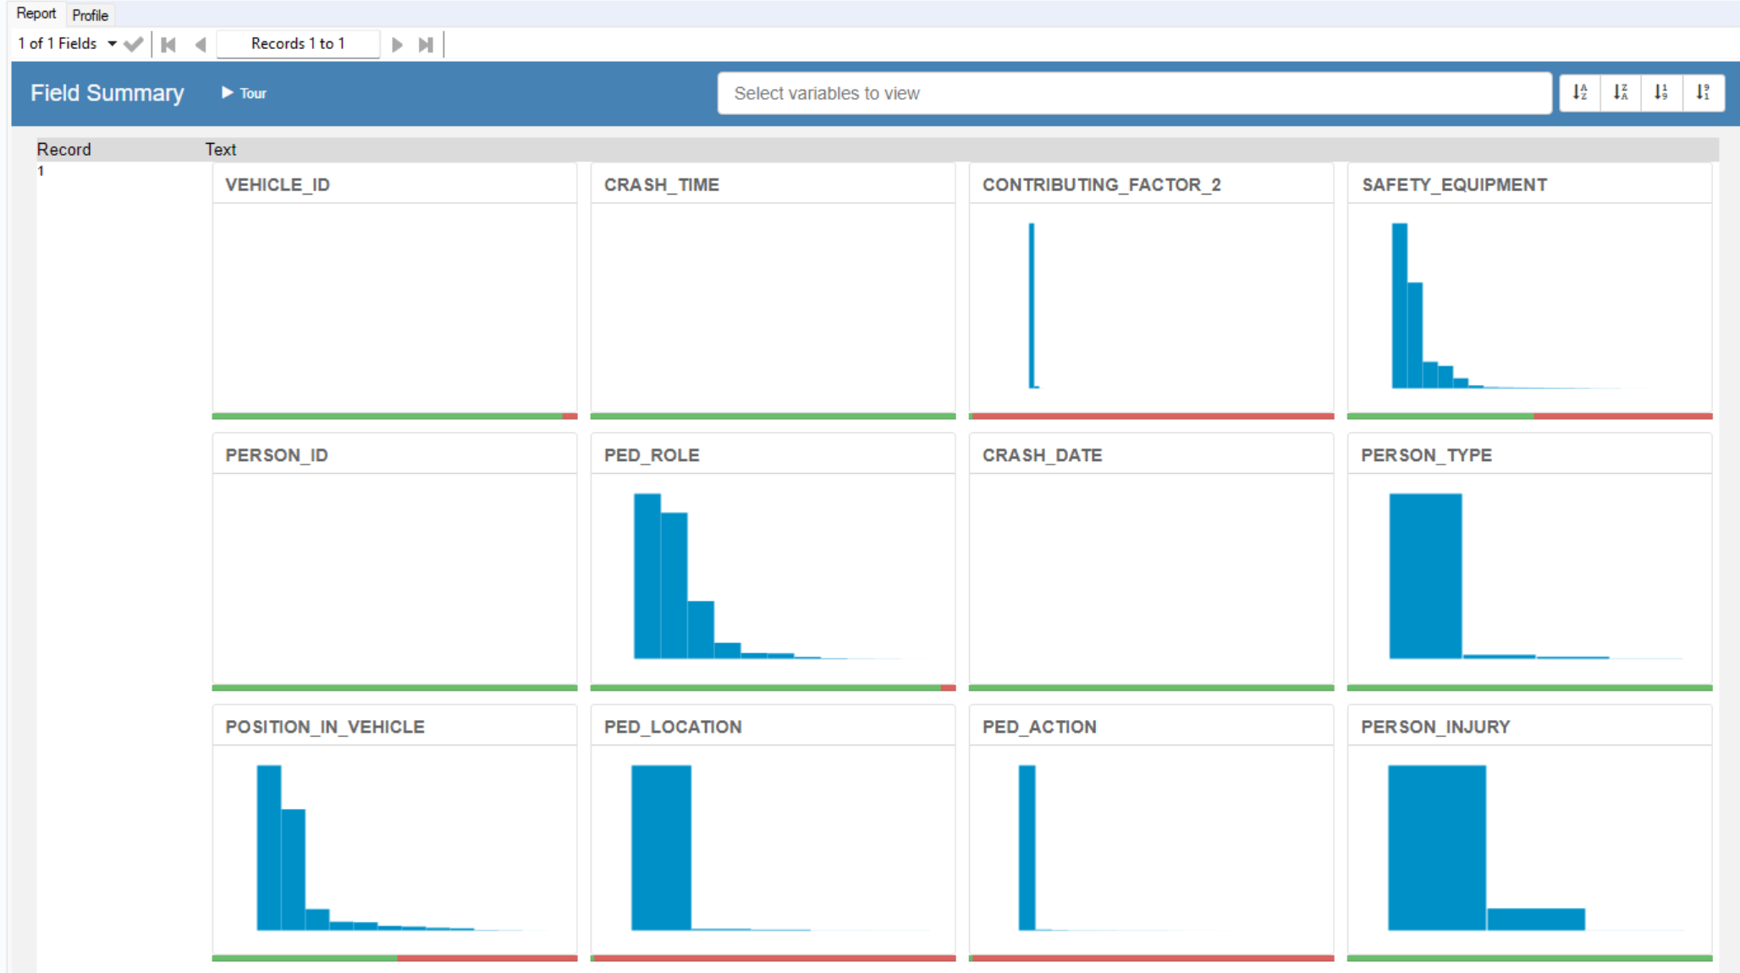

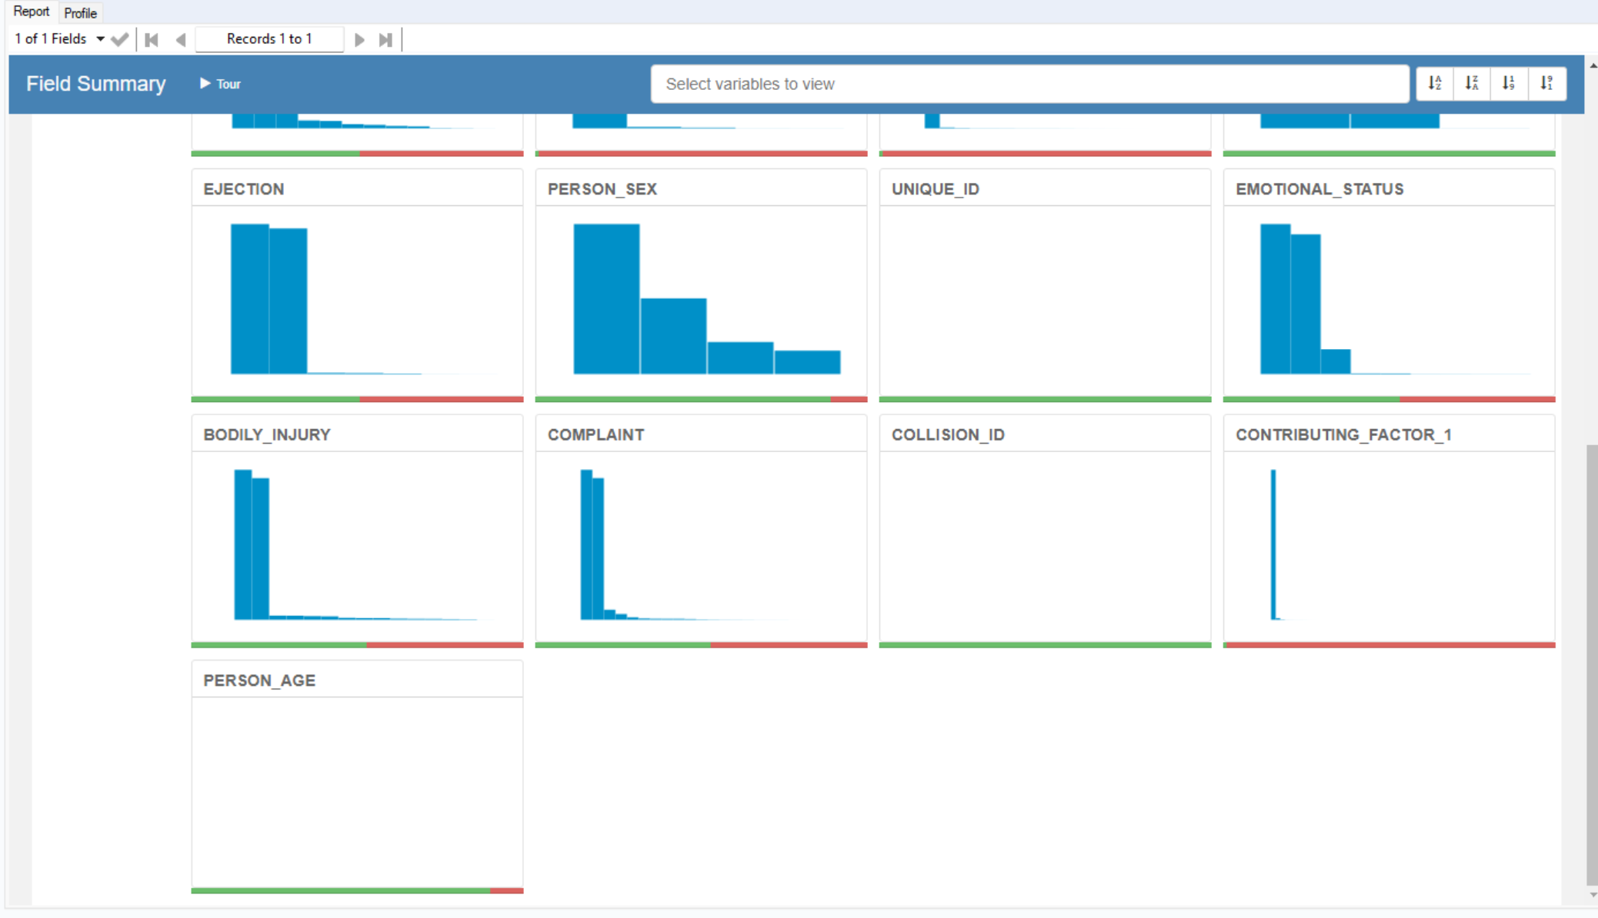

1. Motor_Vehicle_Collisions – Vehicles:

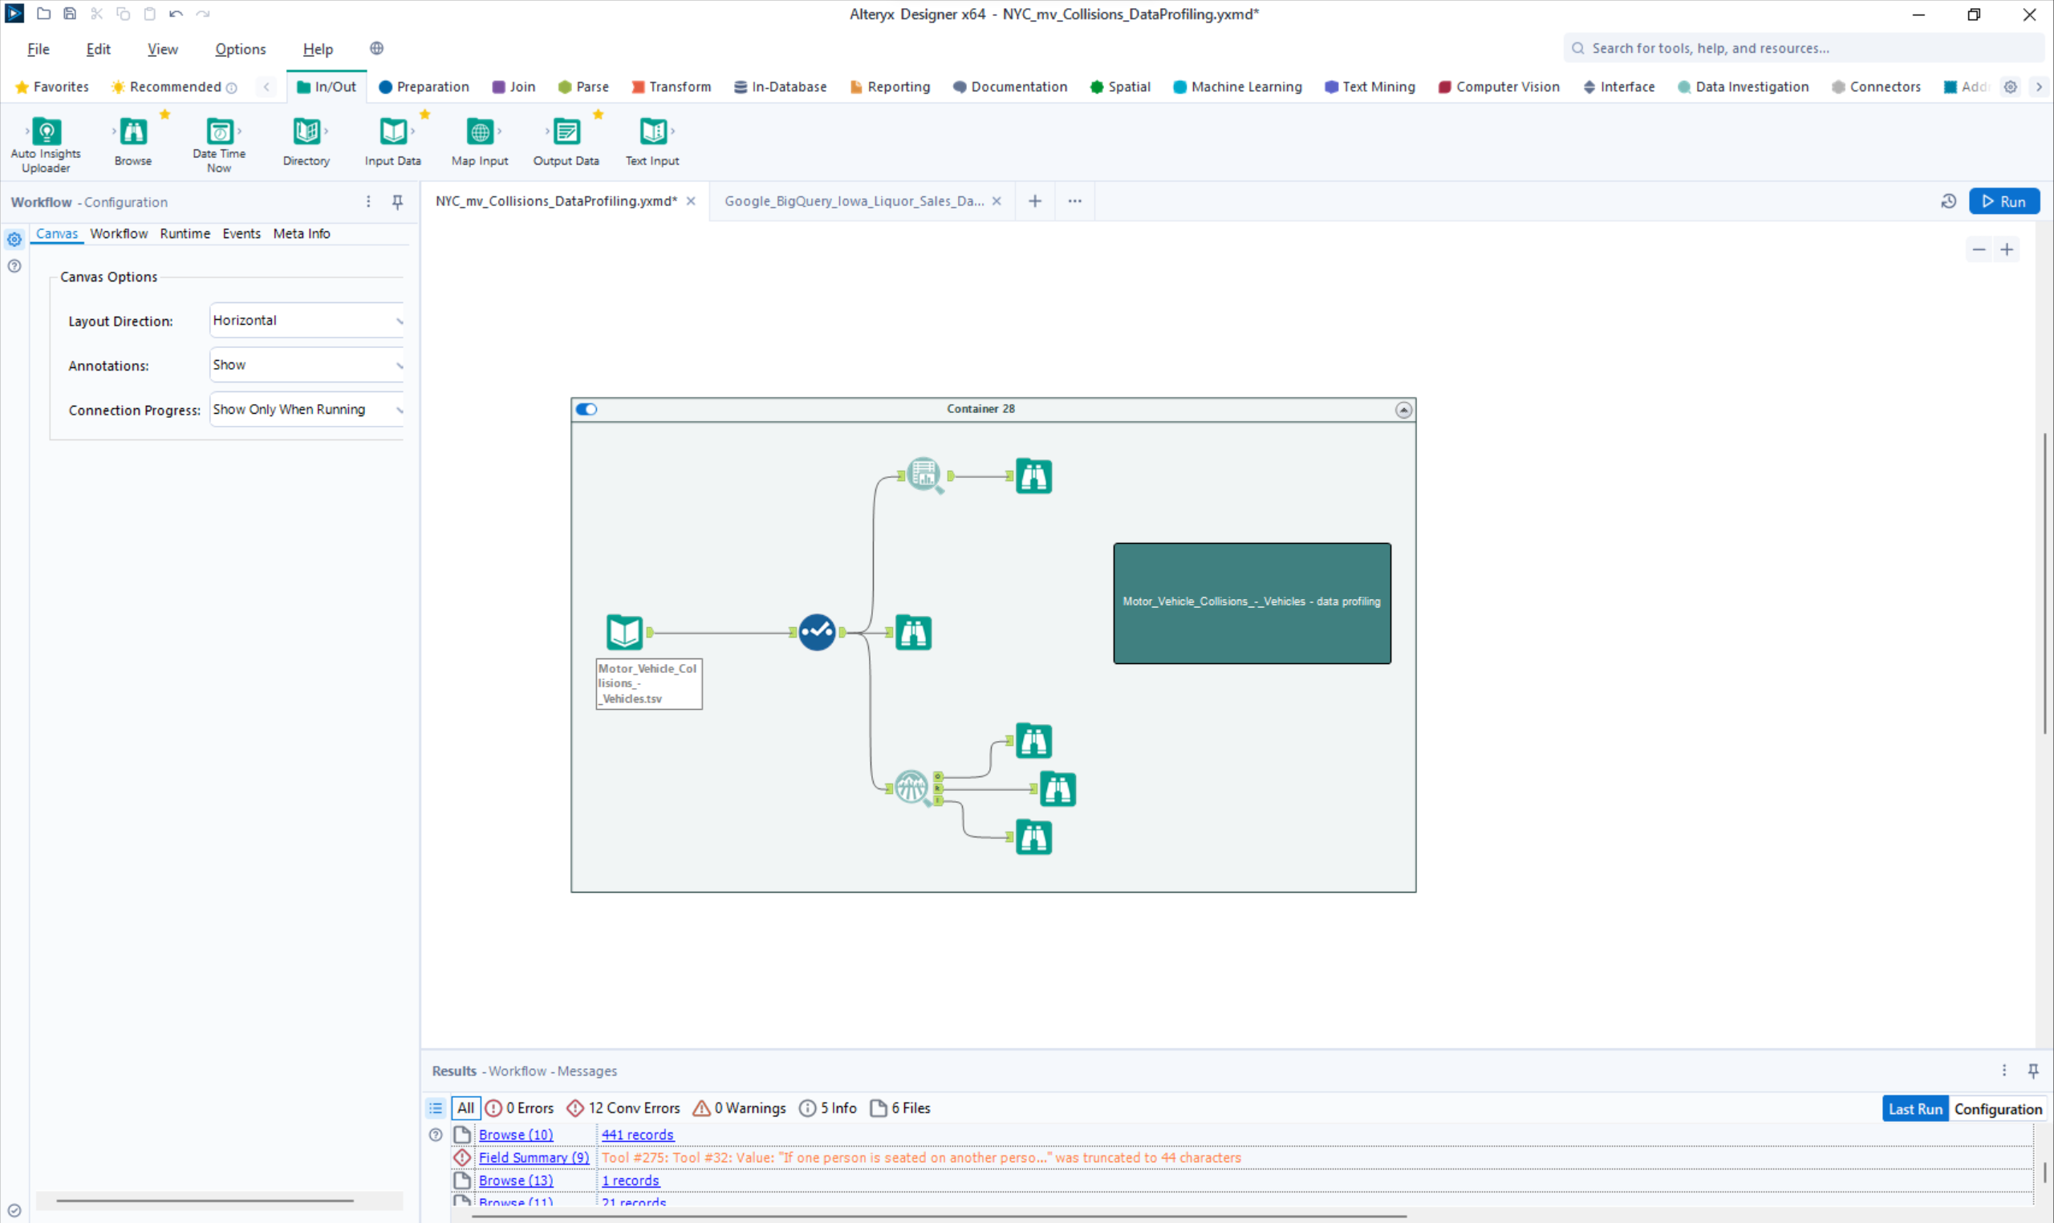

Time Alteryx job took: 24.0 s

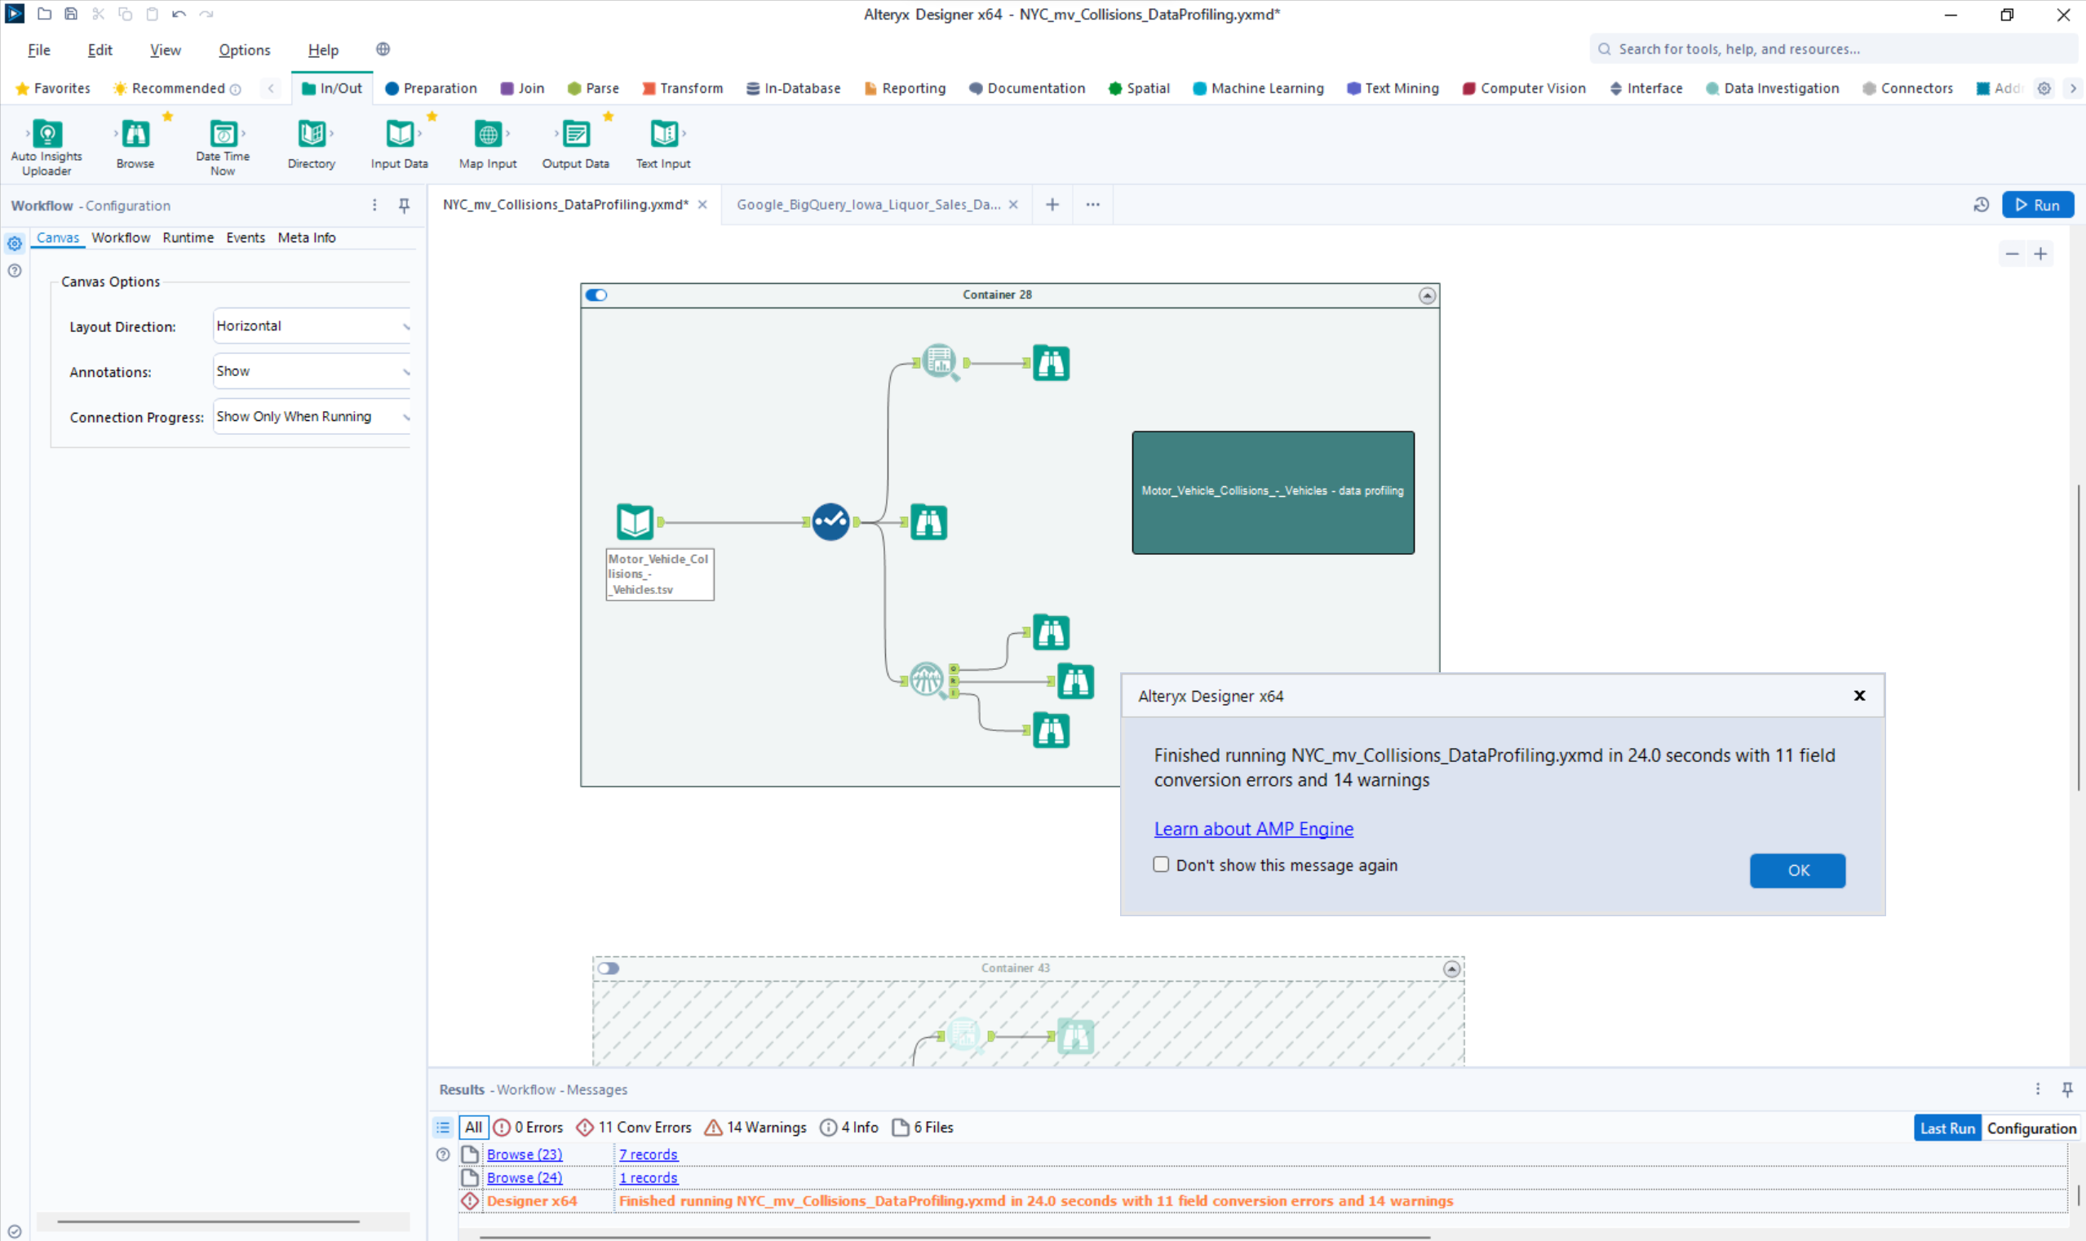

**Data profiling notes - Motor_Vehicle_Collisions_-_Vehicles**

* Contributing_Factor_1: There are null values in this field that need cleansing – 117803 nulls. We shall replace the null values with “Unknown.”
* Contributing_Factor_2: There are null values in this field that need cleansing – 1650688 nulls. We shall replace the null values with “Unknown.”
* Public property damage type: There are null values in this field that need cleaning -3704400.
* Vehicle Damage_1: There 65.24% null values in this field that need cleaning.
* Vehicle Damage_2: There 74.14% null values in this field that need cleaning .
* Vehicle Damage_3: There 80.34% null values in this field that need cleaning
* Vehicle Damage: There 45.33% null values in this field that need cleaning
* Point_of_impact: There 44.87% null values in this field that need cleaning
* Pre-crash : There 23.83 null values in this field that need cleaning
* Driver_license_jurisdiction: There 56.97% null values in this field that need cleaning
* Driver license status: There 57.18% null values in this field that need cleaning
* Driver_sex: There 55.33% null values in this field that need cleaning
* Vehicle_occupants: There 46.39% null values in this field that need cleaning
* Travel_direction: There 44.12% null values in this field that need cleaning
* Vehicle_Year: There 48.51% null values in this field that need cleaning
* Vehicle_model: There 98.61% null values in this field that need cleaning

**Field Summary tool:**

Output:

 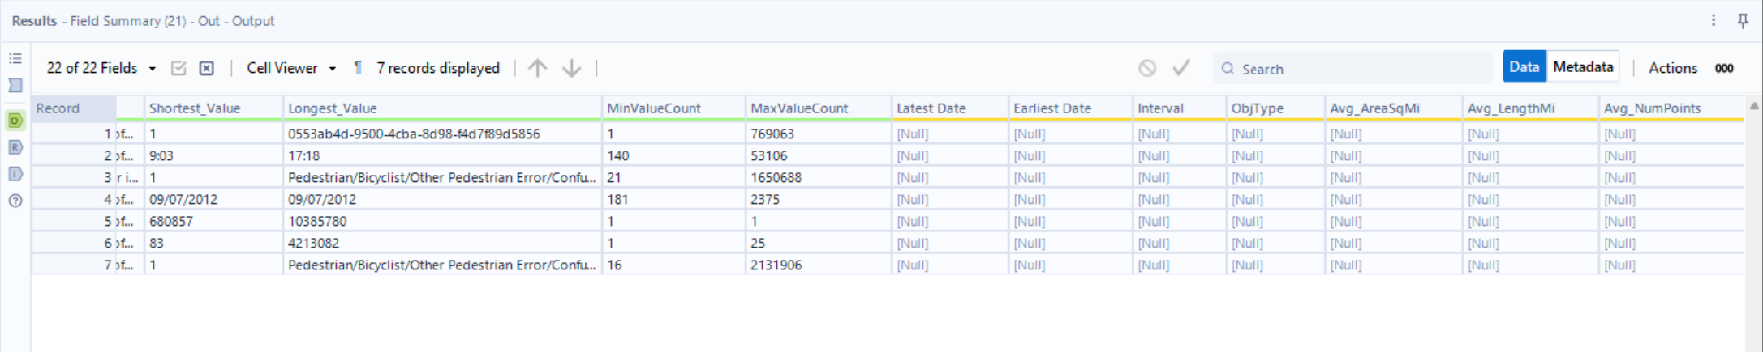

Reports:



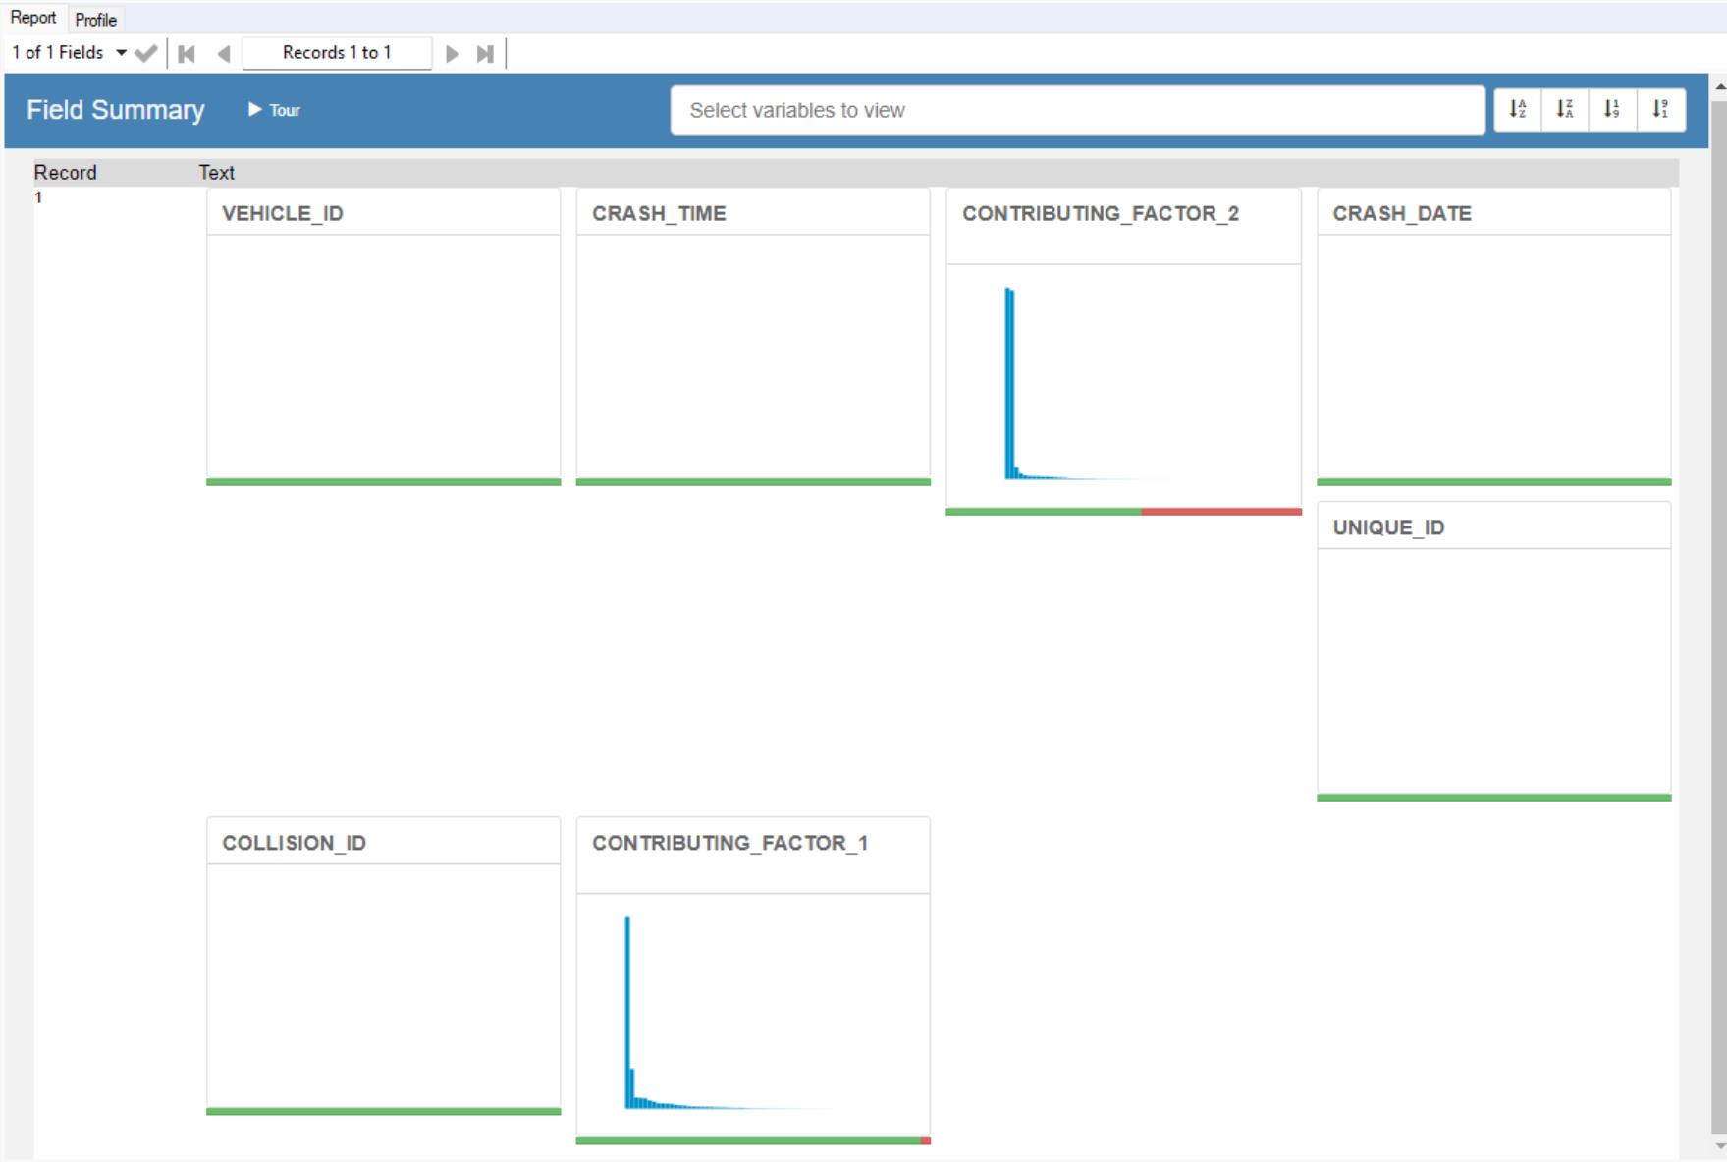

1. Motor_Vehicle_Collisions – BigQuery:

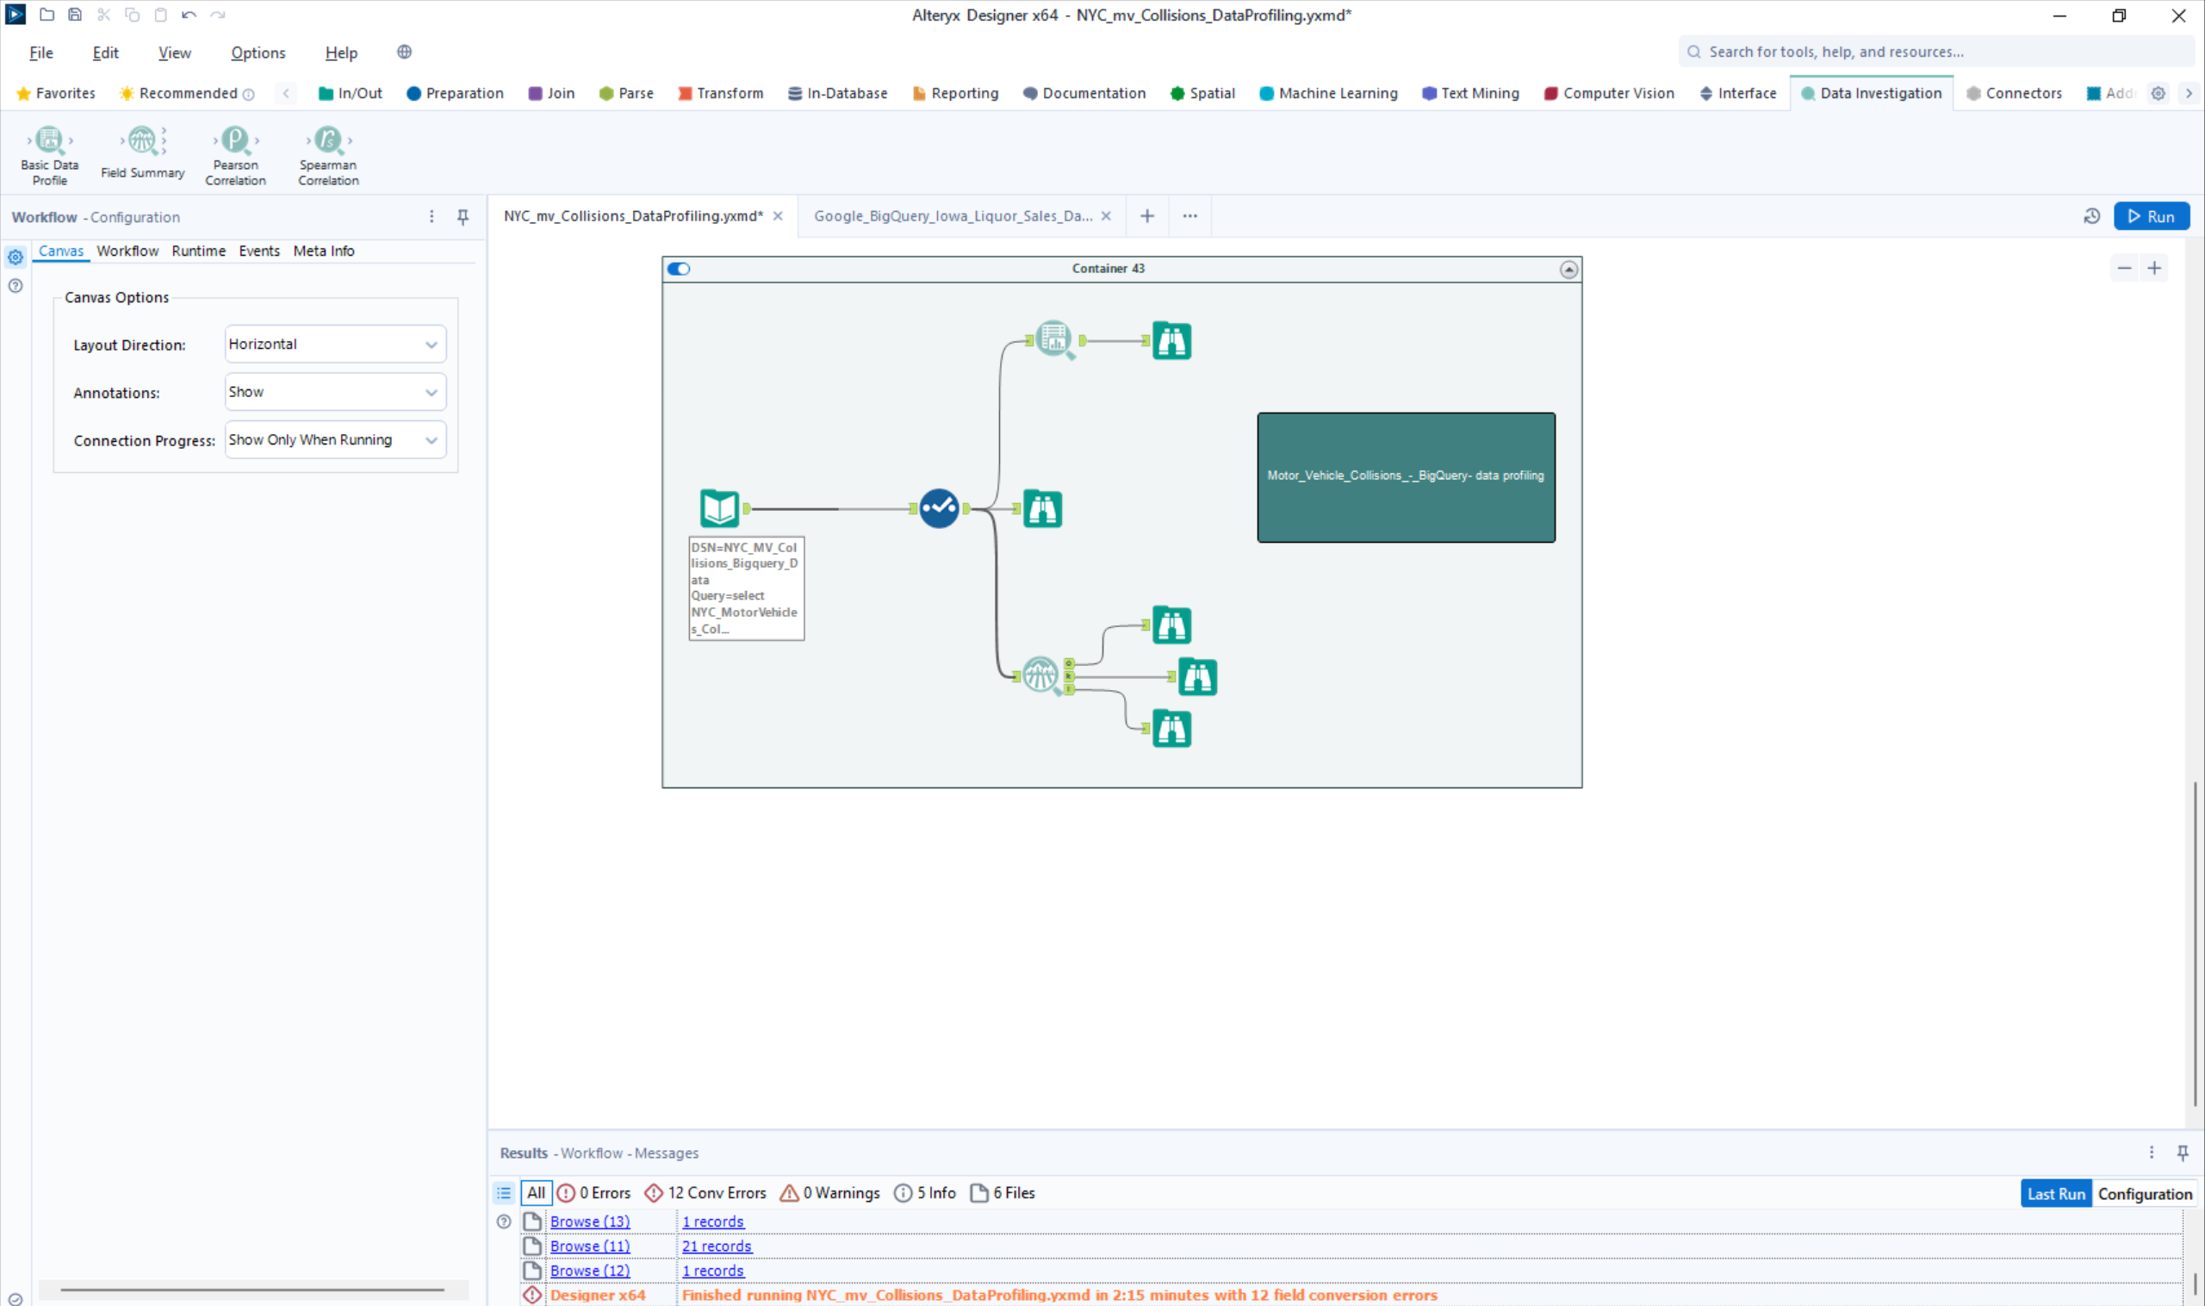

Time Alteryx job took: 2:05s

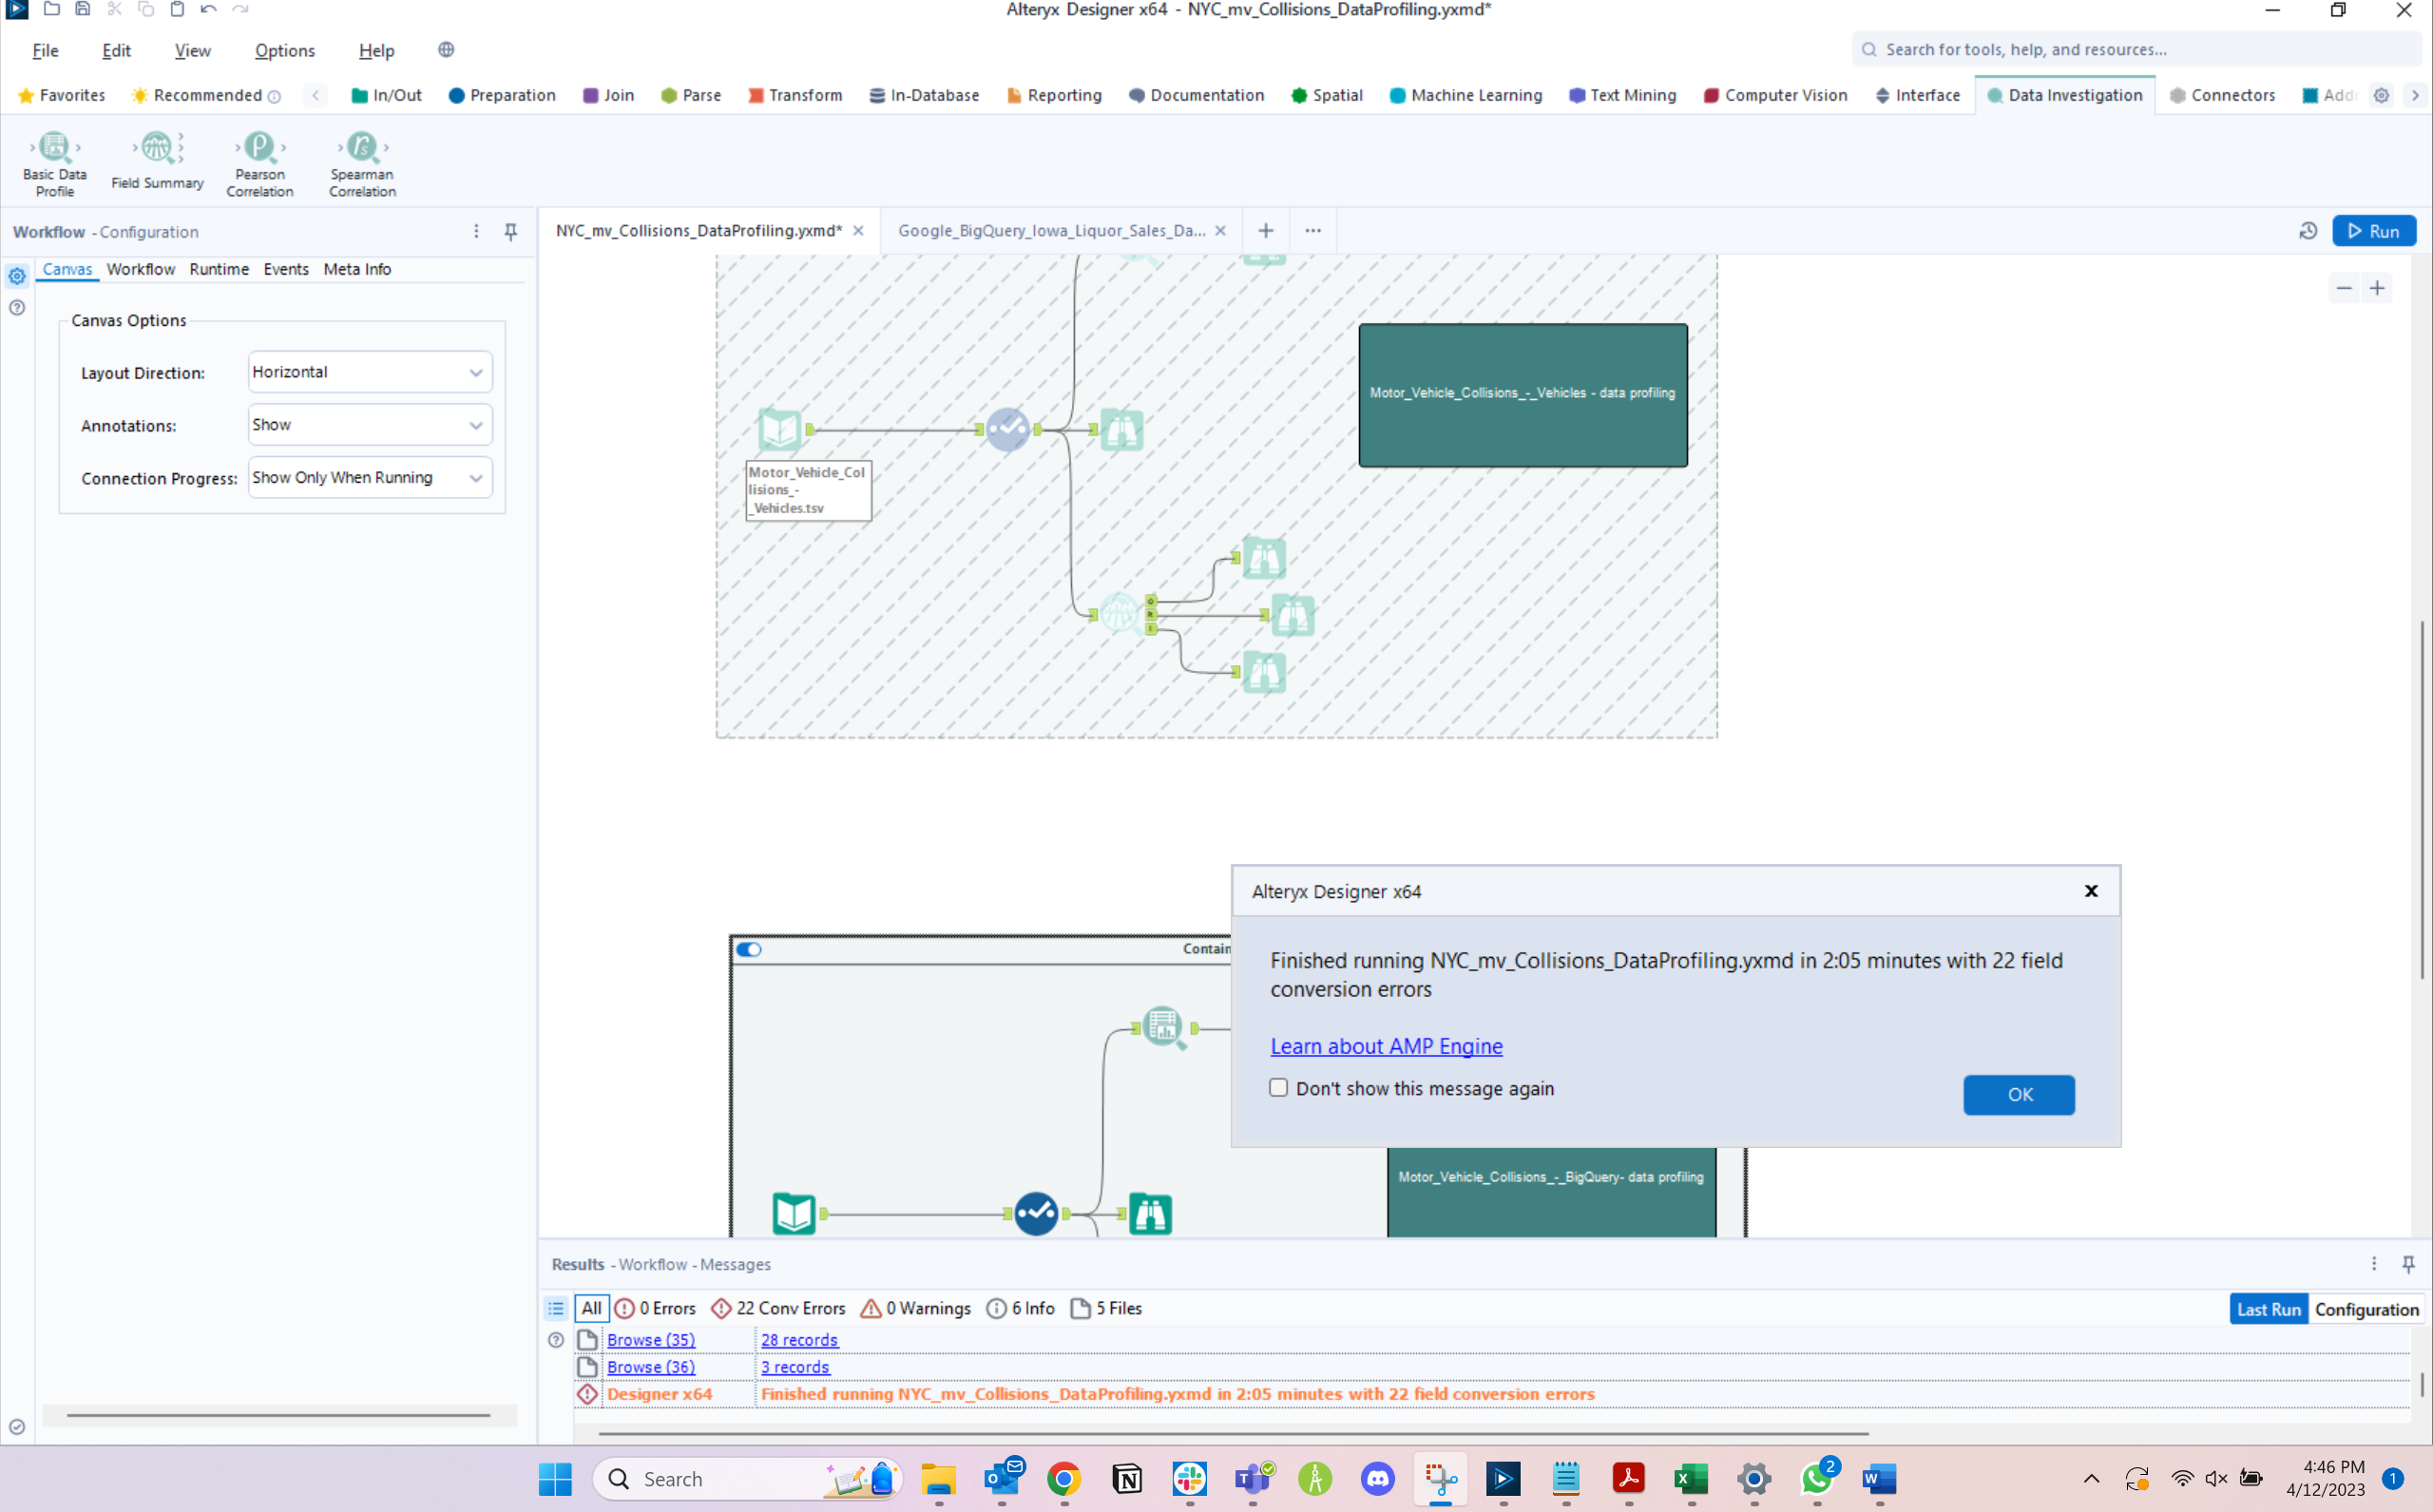

**Data profiling notes - Motor_Vehicle_Collisions_-_BigQuery:**

* Borough: There are null values in this field that need cleansing – 616621 nulls. We shall replace the null values with “Unknown.”
* Contributing_factor_vehicle_1: There are null values in this field that need cleansing – 6155 nulls. We shall replace the null values with “Unspecified.”
* Contributing_factor_vehicle_2: There are null values in this field that need cleansing – 300297 nulls. We shall replace the null values with “Unspecified.”
* Contributing_factor_vehicle_3: There are null values in this field that need cleansing – 1843185 nulls. We shall replace the null values with “Unspecified.”
* Contributing_factor_vehicle_4: There are null values in this field that need cleansing – 1951714 nulls. We shall replace the null values with “Unspecified.”
* Contributing_factor_vehicle_5: There are null values in this field that need cleansing – 1974553 nulls. We shall replace the null values with “Unspecified.”
* Cross_street_name: There are null values in this field that need cleansing – 737090 nulls. We shall replace the null values with “Unknown.” There are also values with leading and trailing whitespaces which need to be cleansed.
* Latitude: There are null values in this field that need cleansing – 226874 nulls. We shall replace the null values with “-9999.99”.
* Longitude: There are null values in this field that need cleansing – 226874 nulls. We shall replace the null values with “-9999.99”.
* Location: There are null values in this field that need cleansing – 226874 nulls. We shall replace the null values with “-9999.99”.
* Off_street_name: There are null values in this field that need cleansing – 1660556 nulls. There are also 30 Blanks in this field. We shall replace the null and blank values with “NA”. There are also values with leading and trailing whitespaces which need to be cleansed.
* On_street_name: There are null values in this field that need cleansing – 414785 nulls. There are also 15 Blanks in this field. We shall replace the null and blank values with “NA”. There are also values with leading and trailing whitespaces which need to be cleansed.
* Vehicle_type_code1: There are null values in this field that need cleansing – 12184 nulls. We shall replace the null values with “Unknown.” There are also values with leading and trailing whitespaces which need to be cleansed.
* Vehicle_type_code2: There are null values in this field that need cleansing – 365768 nulls. We shall replace the null values with “Unknown.” There are also values with leading and trailing whitespaces which need to be cleansed.
* Vehicle_type_code3: There are null values in this field that need cleansing – 1847933 nulls. We shall replace the null values with “Unknown.” There are also values with leading and trailing whitespaces which need to be cleansed.
* Vehicle_type_code4: There are null values in this field that need cleansing – 1952740 nulls. We shall replace the null values with “Unknown.” There are also values with leading and trailing whitespaces which need to be cleansed.
* Vehicle_type_code5: There are null values in this field that need cleansing – 1974801 nulls. We shall replace the null values with “Unknown.” There are also values with leading and trailing whitespaces which need to be cleansed.
* Zip_code: There are null values in this field that need cleansing – 616901 nulls. We shall replace the null values with “NA.”

**Field Summary tool:**

Output:

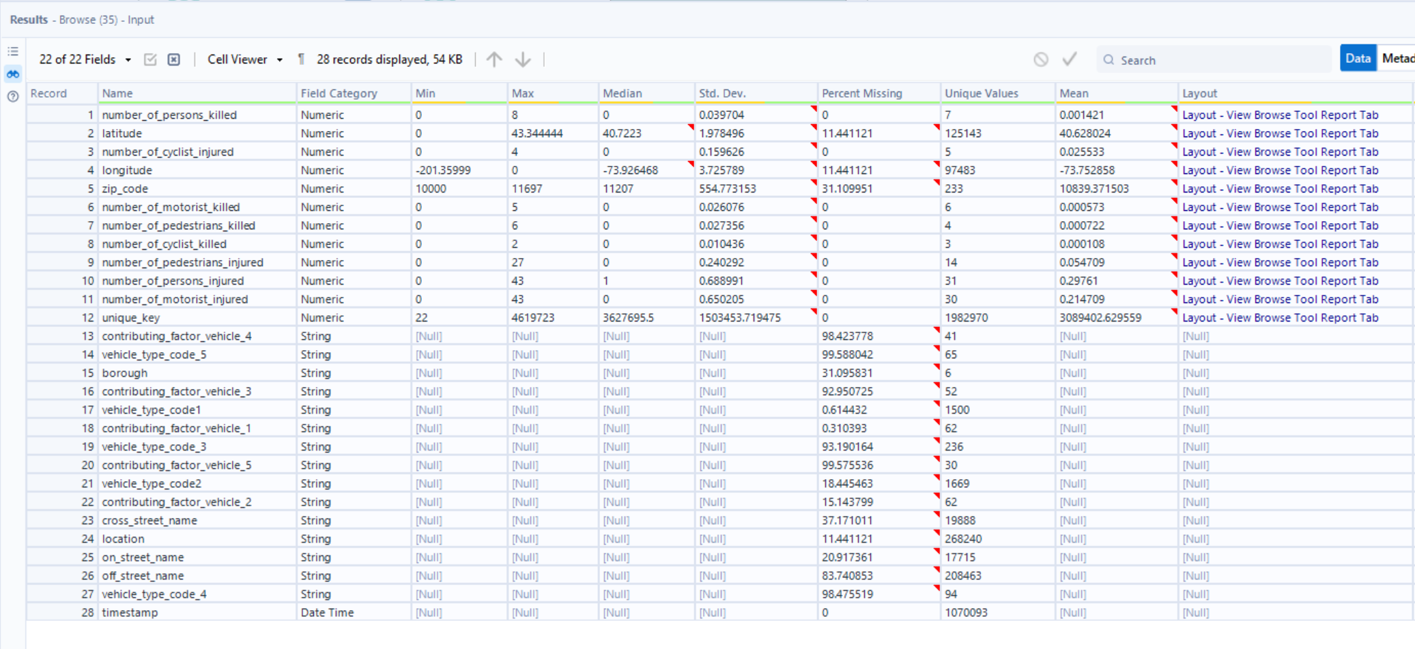

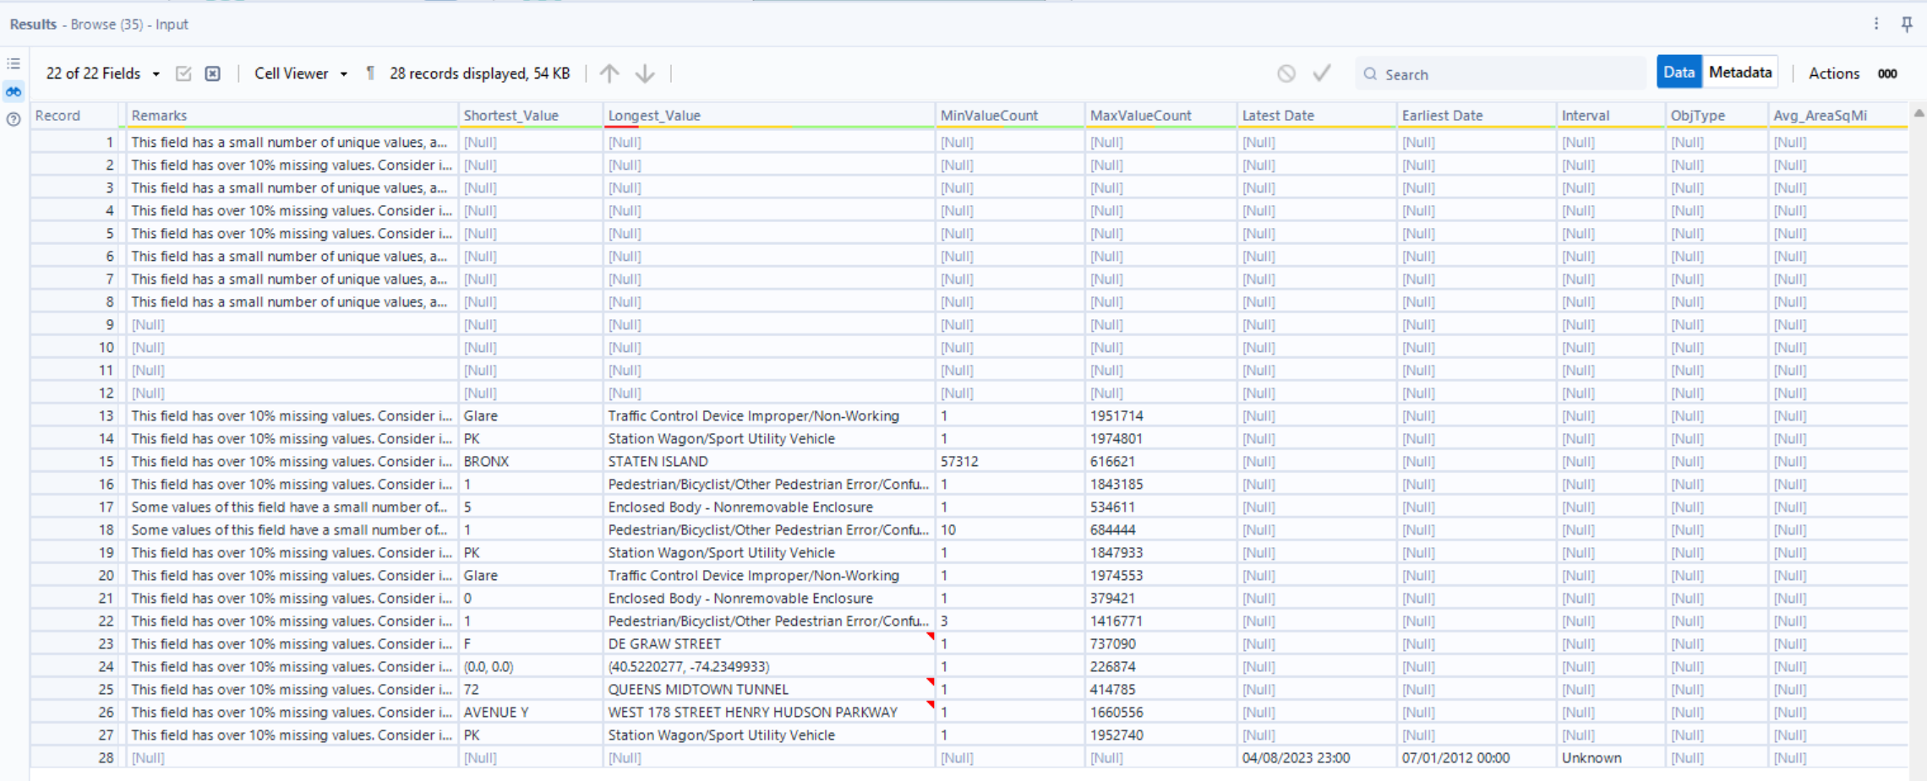

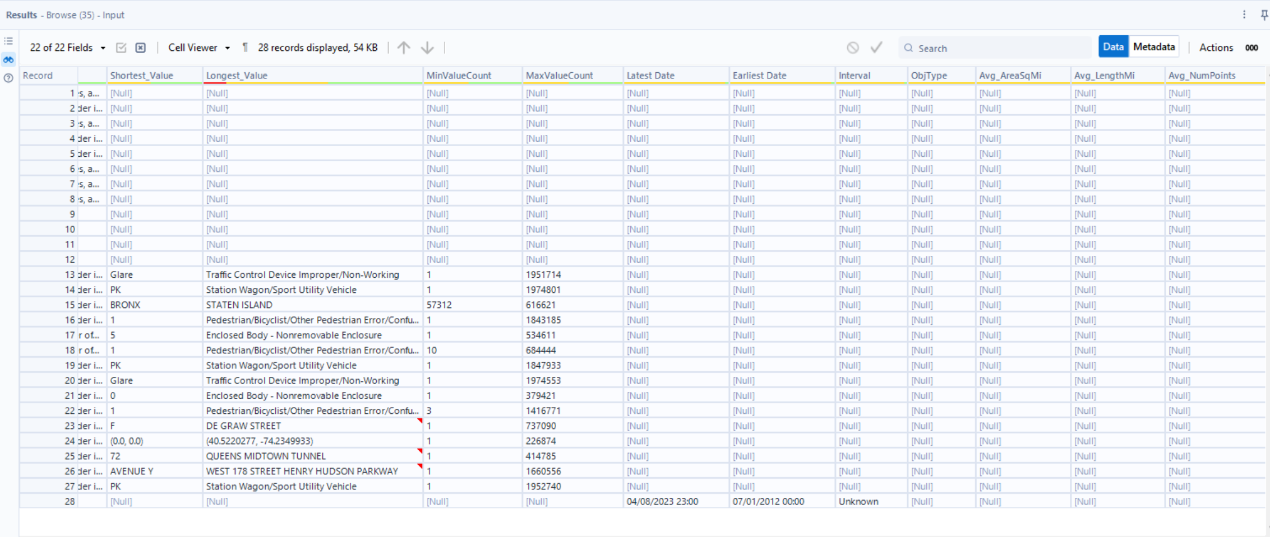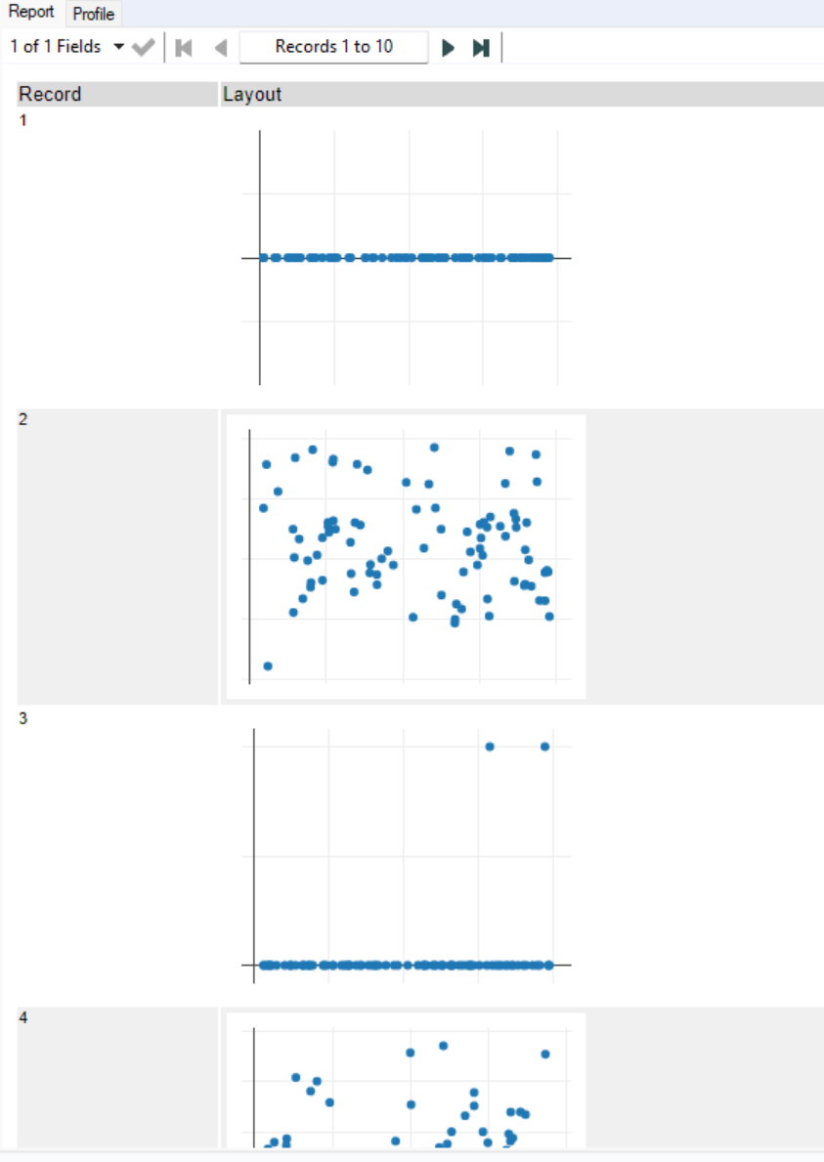 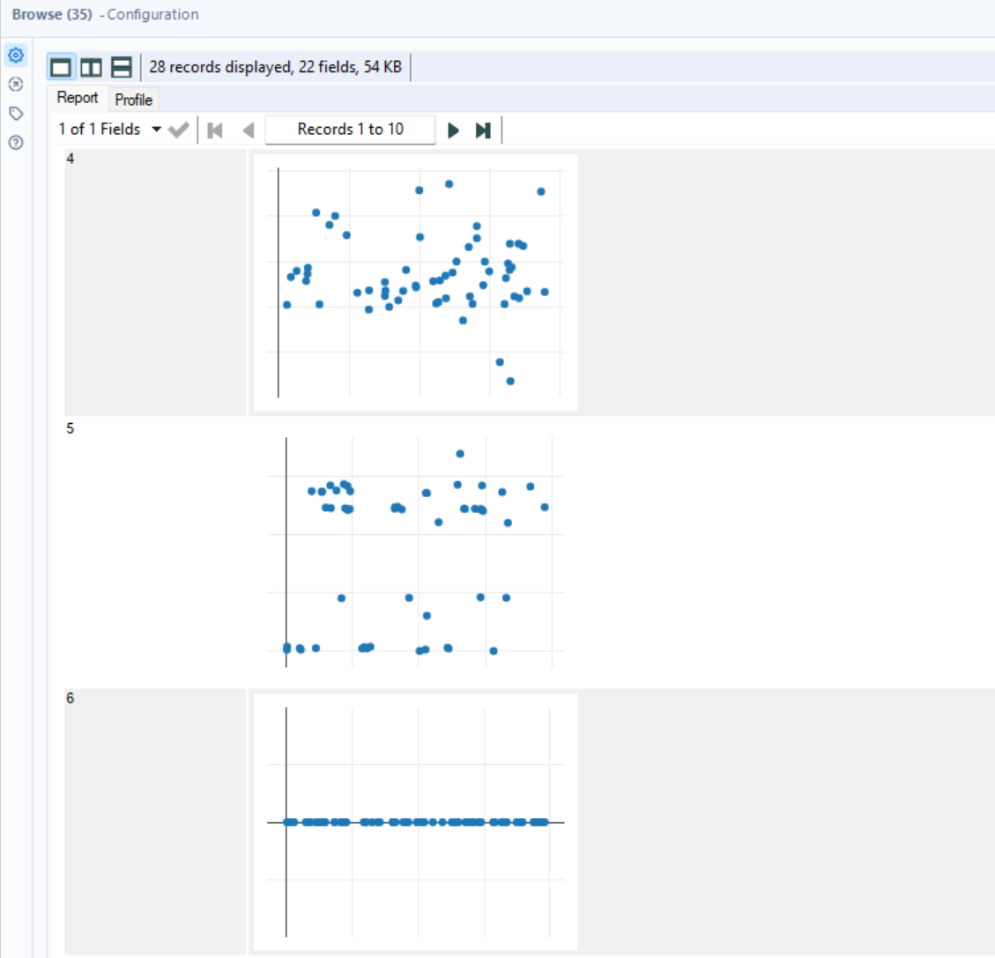

Reports:

